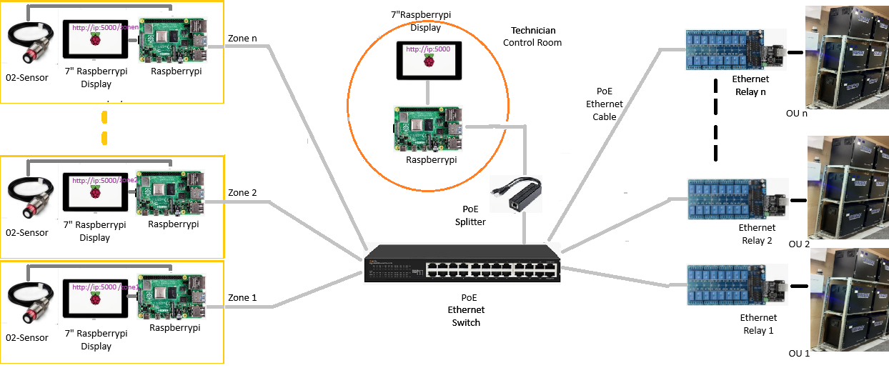
Key Components and Connectivity
- Central Raspberry Pi (Control Room)
  - Role: Serves as the central hub, hosting the web application (accessible at http://ip:5000), managing data flows between zones and Ethernet relays, and interfacing with zone displays.
  - Connectivity:
    - Connected to a PoE Ethernet Switch via an Ethernet cable (via PoE Splitter for power and data).
    - Properly interfaces with Ethernet relays for controlling oxygen units.
    - Hosts the application accessible at http://ip:5000.

- PoE Ethernet Switch
  - Role: Acts as the central network hub, connecting all devices (zones, relays, and Raspberry Pi) and providing power through PoE.
  - Connectivity:
    - Supplies power and data to:
      - Raspberry Pi (via PoE splitter).
      - Raspberry Pi controllers in the zones.
      - Ethernet Relay Modules.
    - Handles communication between zones and the central Raspberry Pi.

- Zone-Level Devices
  - Each zone has:
    - Raspberry Pi: Runs a lightweight web client to display data or interfaces on the Raspberry-pi display screen.
    - 7” Raspberry-pi Display: Connected to the zone Raspberry-pi for displaying the central Raspberry Pi-hosted application.
    - O2 Sensor: Connected to the Raspberry-pi for measuring oxygen levels.
  - Connectivity:
    - Raspberry-pi:
      - The Raspberry-pi in each zone communicates with the central Raspberry Pi over Ethernet via the PoE Ethernet switch.
      - Connected locally to the O2 sensor and Raspberry-pi Display.
    - 7” Raspberry-pi Display:
      - The Raspberry-pi Display and O2 sensor are correctly connected to the Raspberry-pi.
      - Displays the application interface hosted by the central Raspberry Pi (http://ip:5000/zone<n>).
    - O2 Sensor:
      - Provides oxygen data to the Raspberry-pi for further communication to the Raspberry Pi.
      - Ethernet cabling is used for reliable communication between zones and the control room.

- Ethernet Relays
  - Role: Control oxygen units (OU 1, OU 2, OU n) based on commands from the central Raspberry Pi.
  - Connectivity:
    - Connected to the central Raspberry Pi via the PoE Ethernet Switch for power and data.
    - Each relay bank interfaces directly with its corresponding oxygen unit.

Disclaimer
This architecture has been designed based on team current understanding of the project requirements and device connectivity options. I do not claim expertise in the specific technical properties or compatibility of the hardware devices used.
The following aspects should be reviewed by a technical expert with relevant device expertise before proceeding with the purchase or implementation:
- Power Supply for ESP32: Ensure PoE compatibility or adequate power management for the ESP32 modules.
- Distance Limitations: Validate the placement of devices within the 100m Ethernet cable range or plan for extenders if required.
- Device Compatibility: Confirm that all devices (e.g., TFT displays, ESP32, PoE switches, Ethernet relays) are compatible with each other in terms of communication protocols and power requirements.
- Network Load: Evaluate the Raspberry Pi's capability to handle the expected network traffic and processing load.

Action Plan
- Review the Architecture
  - Request you to kindly verify that the connectivity and hardware components are appropriate and meet the project's requirements.
- Approve or Recommend Changes
  - If approved, we can proceed with purchasing the hardware components.
  - If changes are recommended, kindly share the update in the design.

